**Product revenue:**

This file will show the id and name of the product and how much revenue it has generated since its available. It will show as well the total revenue of the products.

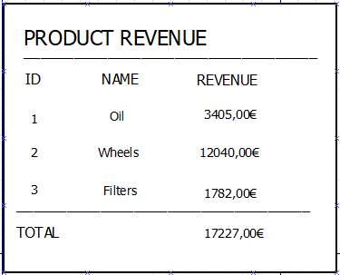

**Employee by position**:

This file will show all the employees of the company grouped by its position.The information shown will be the id, name, surname, address and salary of each of them.

